AWS IAM USER & EC2 ACCESS
Assignment Report
Create an IAM user and configure permissions for AWS resource access

1. Assignment Overview
The objective of this assignment is to create an AWS Identity and Access Management (IAM) user, provide console access, configure permissions, and prepare the user to access and manage AWS resources such as Amazon EC2. The screenshots document the IAM user creation and permission configuration process.

2. Main Objectives
- Create a new IAM user named 'sakshi'.
- Enable access to the AWS Management Console.
- Configure a custom or autogenerated console password and require a password change at first sign-in.
- Attach an AWS managed permission policy to the IAM user.
- Review the permissions before creating the user.
- Verify that the IAM user appears in the IAM console.

3. Step-by-Step Summary

Step 1 – Open IAM Users
The AWS IAM Users page was opened from the AWS Management Console. At the beginning, no IAM users were listed, and the Create user button was available.

Step 2 – Specify User Details
A new IAM user named 'sakshi' was entered. AWS Management Console access was enabled. The screen shows the password configuration area and the option requiring the user to create a new password at the next sign-in.

Step 3 – Set Permissions
An AWS managed policy was selected for the user. The screenshot shows AmazonS3FullAccess selected. This means the captured configuration grants full access to Amazon S3 rather than the AmazonEC2FullAccess policy specified in the original assignment.

Step 4 – Review and Create
The review screen confirms the username 'sakshi', autogenerated console password, and required password reset. The permissions summary lists AmazonS3FullAccess and IAMUserChangePassword.

Step 5 – IAM User Group Screen
The IAM user groups page was opened. A group named 'IAM Group' is being configured, and the user 'sakshi' is visible as an available user. This screen is related to optional group-based permission management.

4. Important Observation
Policy mismatch: The original assignment requires the policy AmazonEC2FullAccess so that the IAM user can launch and manage EC2 instances. However, the provided screenshots show AmazonS3FullAccess selected. Therefore, before testing EC2 access, the user should attach AmazonEC2FullAccess (or otherwise grant the required EC2 permissions) to the IAM user.

5. Next Stage – EC2 Test
After the correct EC2 permissions are attached, the IAM user should be used to sign in to the AWS Management Console and open Amazon EC2. The user can then launch a basic EC2 instance using an appropriate Amazon Linux AMI, a free-tier-eligible instance type when available, and a suitable security group. The assignment specifies allowing SSH (port 22) and HTTP (port 80).
- Sign out of the root account.
- Sign in using the IAM user credentials.
- Open the Amazon EC2 dashboard.
- Choose Launch instance.
- Select an Amazon Linux AMI.
- Choose a suitable free-tier-eligible instance type if available for the account.
- Configure a key pair according to the assignment requirements.
- Configure the security group with SSH (22) and HTTP (80) as required.
- Launch the instance and verify that it appears under EC2 Instances.

6. Screenshot Evidence
Figure 1: IAM Users page before user creation.
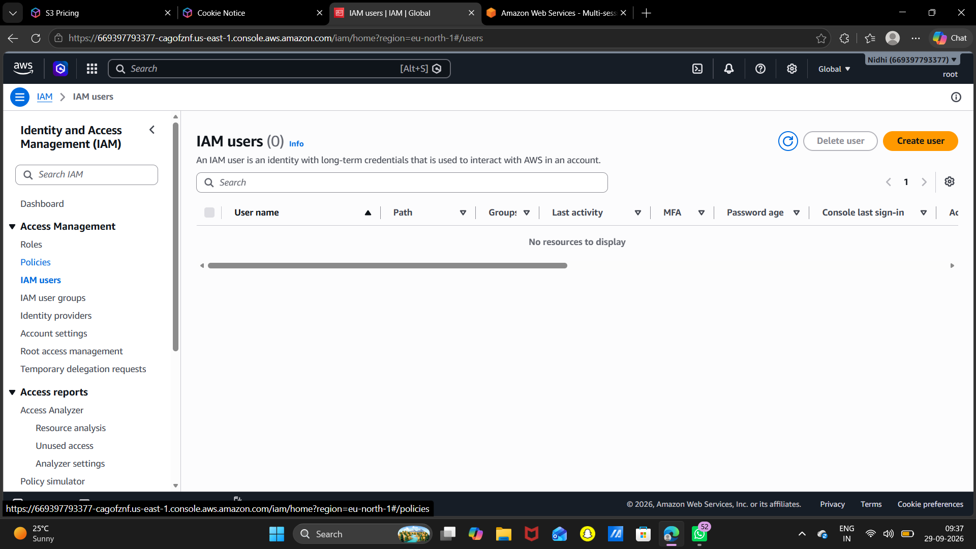
Figure 2: IAM user details and console access configuration.
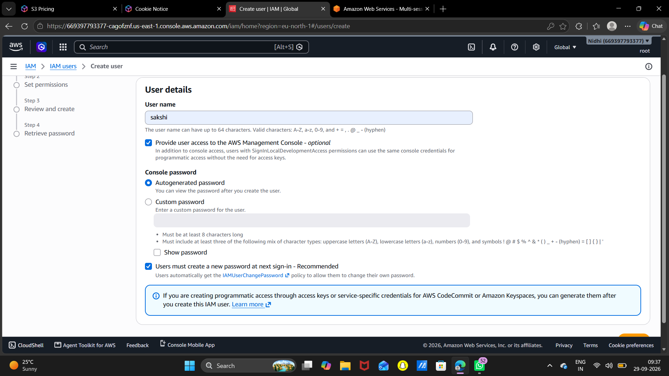
Figure 3: Permissions selection screen.
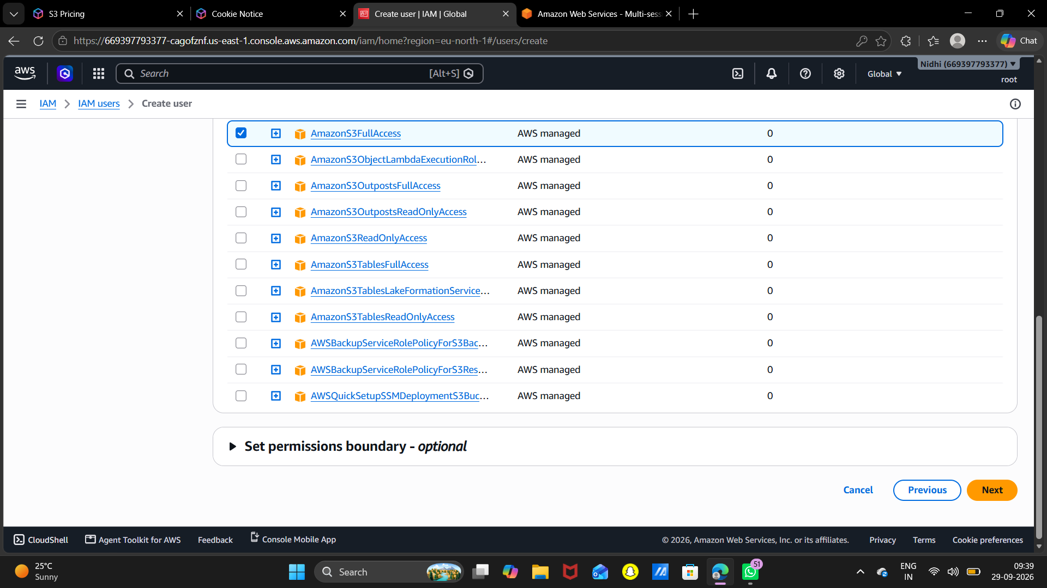
Figure 4: Review and create screen.
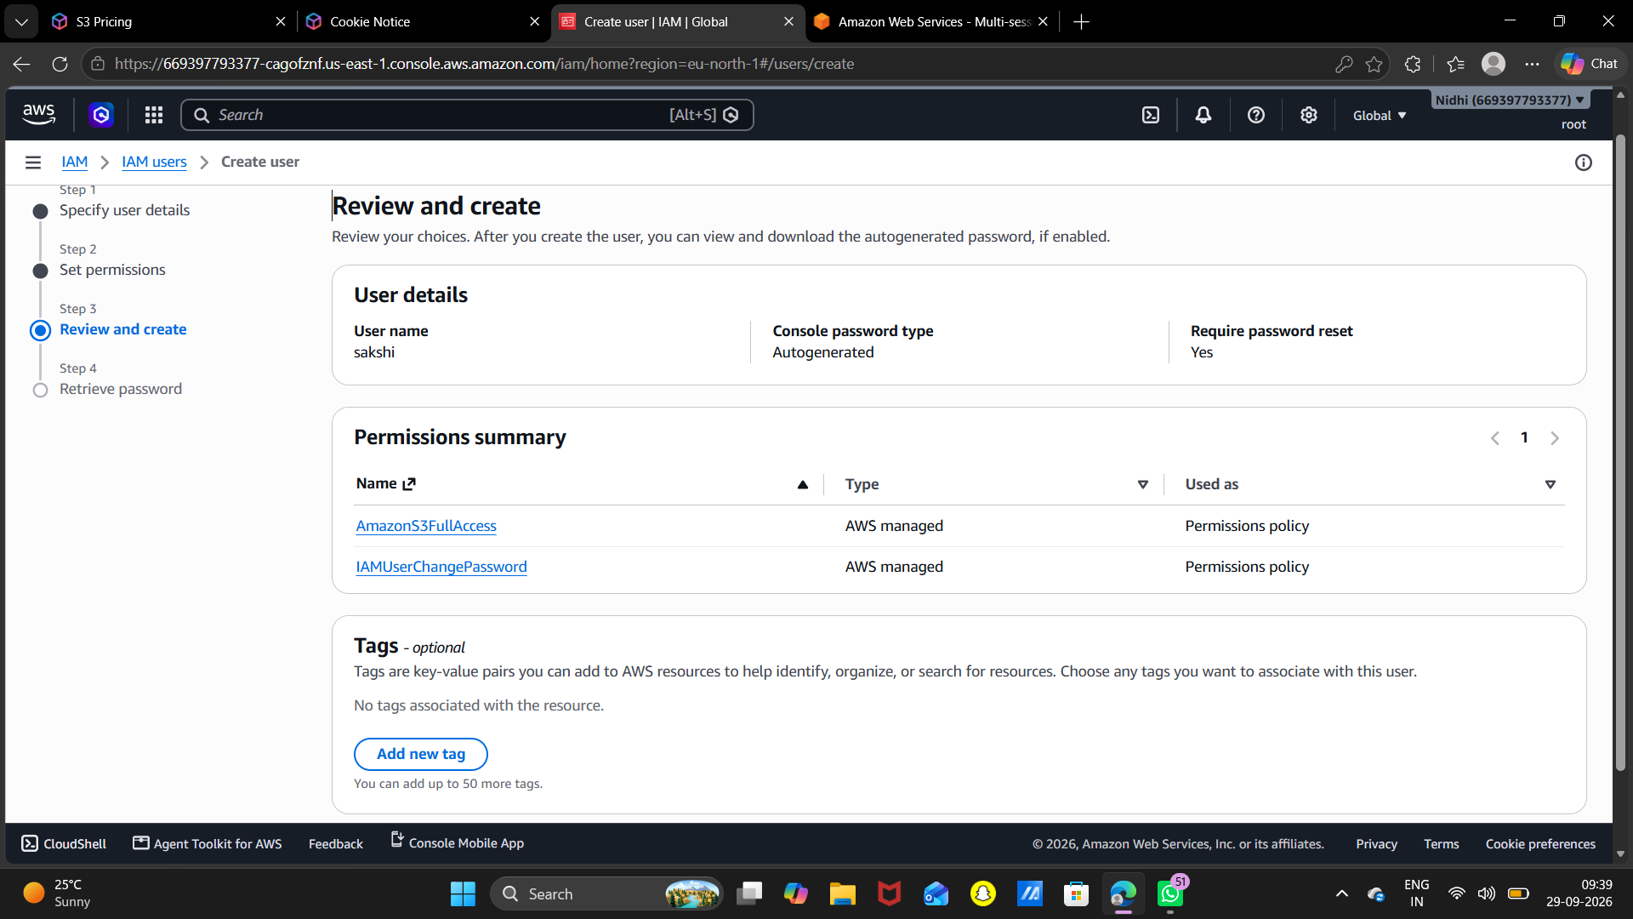
Figure 5: IAM user group creation screen.
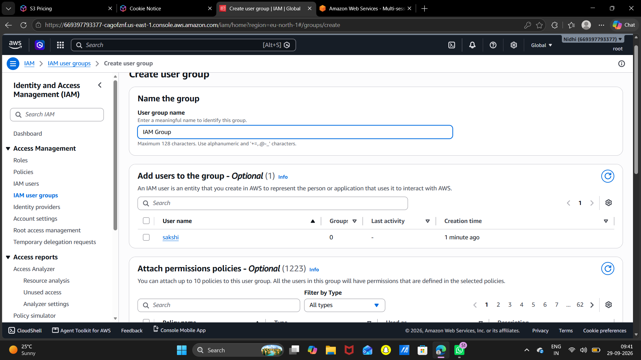

7. Conclusion
The screenshots demonstrate the creation and configuration of an IAM user in AWS, including console access, password settings, and permission assignment. The review screen confirms the user configuration. To complete the stated EC2 assignment, the permission configuration should be corrected to include AmazonEC2FullAccess before performing the EC2 launch test.

